Call for Papers
The 2023 International Conference and Annual Meeting of
Chinese Institute of Transportation, Taiwan

➢ Theme: Vision Zeros: Embracing Safe and Green Transportation for a Better Future
➢ Date: December 7-8, 2023
➢Venue: Chientan Youth Activity Center, No. 16, Sec. 4, Zhongshan N Rd, Taipei City, Taiwan

- Topics:
(1) Air Transportation | (2) Marine Transportation
(3) Railway Transportation | (4) Traffic Engineering
(5) Transportation Planning and  Demand Analysis | (6) Smart City and  Technology Governance
(7) Transportation Economics | (8) Sustainable Transportation
(9) Transportation Safety | (10) Intelligence Transportation and  High-tech Applications
(11) Logistics and Supply Chain | (12) Elderly and Barrier-free  Transportation Services
(13) Tourism Leisure and  Future Travel | (14) Others Transportation Related

- Paper Submission and Reviewing Process:
- Please e-mail your full-text paper to Wang Qing Zhong <r56111189@gs.ncku.edu.tw> in the format of Word (with the extension “.doc” or “.docx”) before August 15th, 2023.
- Submitted papers should follow the paper writing format as attached.
- Paper Submissions:
  - Please indicate the paper field and the author's name, affiliation, title, and E-mail. (Note: The Academic Affairs Committee reserves the right to decide on the field of submitted papers).
  - The maximum length of submitted papers is limited to 25 pages.
- The Academic Affairs Committee will invite experts in related fields to review the submitted papers. Authors would be notified the review results on October 1st, 2023.
- This paper submission channel is only for those papers not being considered as the candidates of paper awards. If you prefer your papers to be considered as the one of the award candidates, please submit your papers online https://cit.org.tw/paper/include/index.php by August, 15th, 2023

Submission Contact: Wang Qing Zhong  E-mail: r56111189@gs.ncku.edu.tw  Chair, Academic Affairs Committee  Prof. Ching-Fu Chen  E-mail: cfchen99@mail.ncku.edu.tw | Conference Organizing Committee:  Tamkang University  Department of Transportation Management

2023 International Conference and Annual Meeting, Chinese Institute of Transportation
(Upper left corner on the first page)
Title (Paper Title in English)
NAME (Author’s name)
NAME (Author’s name)
Abstract
Traffic delay has been an important issue for government. However, most of the previous research emphasized on measuring the reliability of transportation service. There is no research in the area of delay compensation. In this research, the feasibility of introducing delay compensation into the frequently delayed passenger flights is studied from the marketing point of view. In addition, with the Logit choice model and revenue maximization, the optimal delay compensation is developed. As to the amount of money to be compensated for flight delay, it is suggested that low compensatory policy should be adopted when the flight delay occurs frequently. On the contrary, when the flight is relatively punctual, the higher compensatory policy will be better.
Keywords: flight delay, compensation, marketing (Keywords)

Introduction (Title1)
There are common problems with delays in public transportation. In particular, the aviation industry faces more uncertain factors such as weather and mechanical failures than other transportation systems. Therefore, flight cancellations, delays or temporary changes to schedules often occur. (Paper Content)

1.1 Flight delay determination procedure (Titie2)
The purpose of this research is mainly to compensate passengers for the loss of time value of the delay caused by the improper operation of the airline. Therefore, no matter in the determination of the delay or the calculation of the delay time, the liability of the airline must be considered. In the past, the general delay determination and time calculation methods are not applicable. Therefore, this study utilizes the concept of responsibility attribution to divide the delay time into two parts, attributable to the airline and non-attributable to the airline, and takes the flight arrival time as the benchmark as the determination of compensation for delay time. (Paper Content)
Therefore, by deducting the airline’s various exemptions from the total delay time, the compensated delay time will be calculated in equation (1).
(1)
Equation
Where,
T ： Total delay time＝Actual arrival time－Original arrival time (by timetable) (Formula description)
T¹ ： Grounded time due to bad weather

1.1.1 Paper Submission and Reviewing Process (Title3)

1. Please e-mail your full-text paper electronic file to Wang Qing Zhong (r56111189@gs.ncku.edu.tw ) before August 15th, 2023. Submitted papers should follow the paper writing format as attached. Please indicate the paper field and the author's name, affiliation, title, and E-mail. (Note: The Academic Affairs Committee reserves the right to decide on the field of paper submission). (Style1)

The maximum length of submitted papers is limited to 25 pages, and the file format includes Word (with the extension “.doc” or “.docx”) and PDF.
The Academic Affairs Committee will invite experts in related fields to review the submitted papers. Authors would be notified the review results on October 1st, 2023. (Style1 Content)
Table 1 Call-for-Paper fields (Table title)
(1) Air Transportation | (2) Marine Transportation
(3) Railway Transportation | (4) Traffic Engineering
(5) Transportation Planning and  Demand Analysis | (6) Smart City and  Technology Governance
(7) Transportation Economics | (8) Sustainable Transportation
(9) Transportation Safety | (10) Intelligence Transportation and  High-tech Applications
(11) Logistics and Supply Chain | (12) Elderly and Barrier-free  Transportation Services
(13) Tourism Leisure and  Future Travel | (14) Others Transportation Related

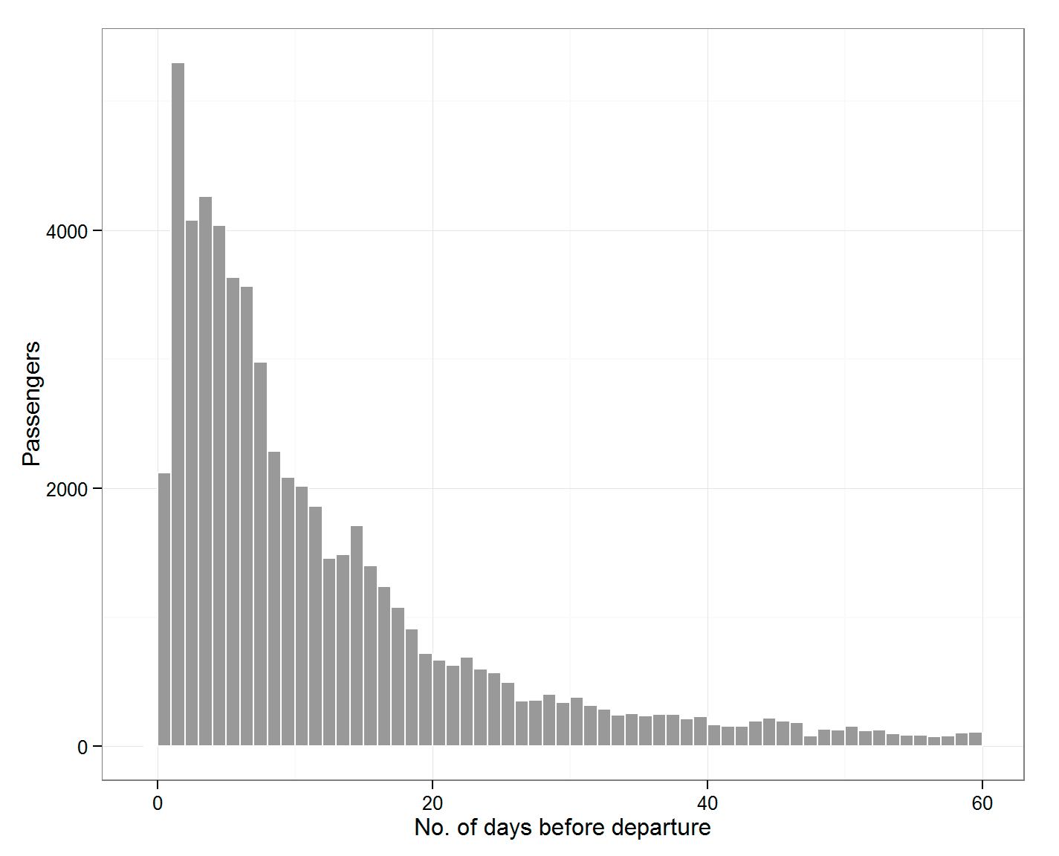
Figure 1 Total number of advance purchases prior to departure (Figure title)

References（Title1）
Babakus, E. and Boller, G. W. (1992), “An Empirical Assessment of the SERVQUAL Scale,” Journal of Business Research, Vol. 24, No. 3, pp. 253-268.
Carbaugh, D. C. (2000), “Vertical Situation Awareness Display,” Joint meeting of the FSF 53rd annual International Air Safety Seminar (IASS), IFA 30th International Conference and IATA, pp. 289-298.
Det, N. V. (2001), Service for International Recognition of R.O.C. Seafarer Certification and Assessment & Planning of Training Qualified Teachers, Courses, Materials and Equipment According to the Requirement of STCW, Technical Report, No. TAI-2000-0420-1.
Jones, S. G. (1996), Human Error: The Role of Group Dynamics in Error Tolerant Systems, Ph. D. Thesis, The University of Texas at Austin.
Simchi-Levi, D., Kaminsky, P. and Simchi-Levi, E. (2000), Designing and Managing the Supply Chain Concepts, Strategies and Case Studies, New York: McGraw-Hill.
Brewster, R. M., Dick, V. R., Inderbitzen, R. E., and Staplin, L. (2007), Health and Wellness Programs for Commercial Drivers, Retrieved July 27, 2007, website: http://onlinepubs.trb.org/onlinepubs/ctbssp/ctbssp_syn_15.pdf.

This work was supported by the Ministry of Science and Technology under Project Number MOST 110-xxxxxxxx-.
Professor, Department of Transportation and Communication Management Science, National Cheng Kung University. No. 1, University Rd., East Dist., Tainan City. E-mail address: author@mail.ncku.edu.tw).
MS, Department of Transportation and Communication Management Science, National Cheng Kung University.

